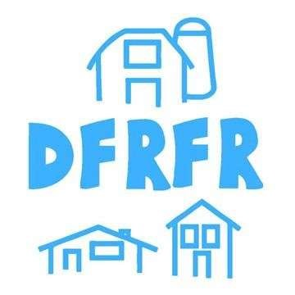
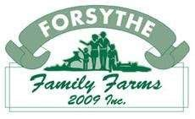
  - Fall Harvest

Fundraiser
Durham Farm & Rural Family Resources is proud to present our latest fundraiser in support of our On Farm Child Care Program. We have partnered with our friends at Forsythe Family Farms to bring you Seasonal Produce Bags - $25/bag. Entry to enjoy all the farm has to offer included with purchase.
Where: Forsythe Family Farms
1025 Cragg Road, Uxbridge
When: Sunday October 2nd, 2022
Time: 10am-2pm

Please place your orders at the following link

https://docs.google.com/forms/d/e/1FAIpQLSdGNy_RA38yG42GPVNGwi3WW8bpyIXcYwKQnuVv5Zd4U-Uvig/viewform

Or scan the QR Code below

